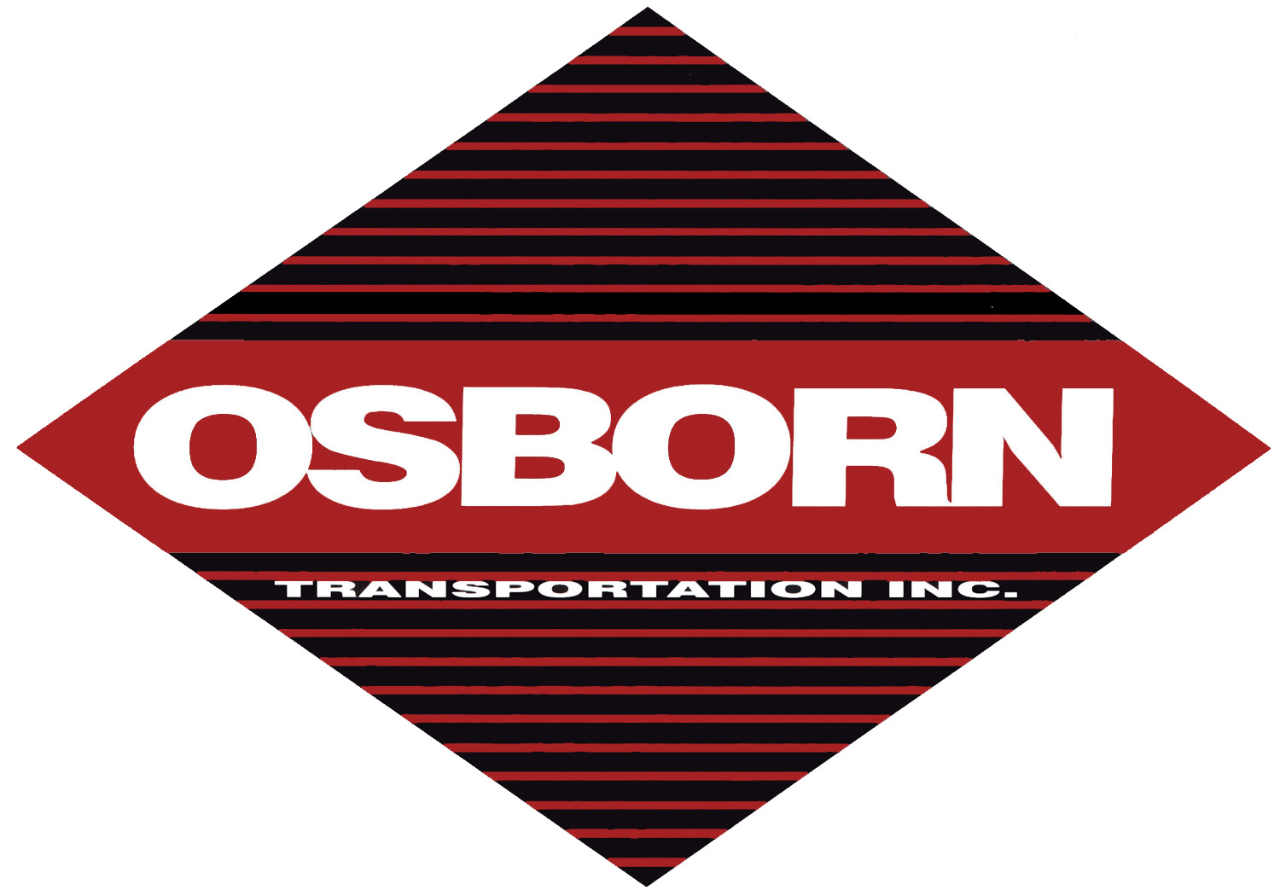
OSBORN TRANSPORTATION INC.

Driver Pre-Employment Application

Please save this form to your computers desktop then fill out the form below and e-mail to: johnw@osborntransportation.com
OR print and fax to John Westerfield at: (256) 413-0002

Date: / /
Name Social Security # - -
Phone # ( ) - Date of Birth / /
Address
City State Zip Code
E-mail Address
Recommended by
Current Drivers License # State Exp. Date / /
Previous Drivers License # State
Number of citations Number of Accidents
Do you have any felony convictions?
Do you have any license suspensions?
Name of Driving School

PRESENT OR LAST EMPLOYER
Name Phone # ( ) -
Address
City State Zip Code
Number of States Employed From (mo/yr) / To (mo/yr) /

Reason for leaving position held

PREVIOUS EMPLOYER
Name Phone # ( ) -
Address
City State Zip Code
Number of States Employed From (mo/yr) / To (mo/yr) /

Reason for leaving position held

PREVIOUS EMPLOYER
Name Phone # ( ) -
Address
City State Zip Code
Number of States Employed From (mo/yr) / To (mo/yr) /

Reason for leaving position held

