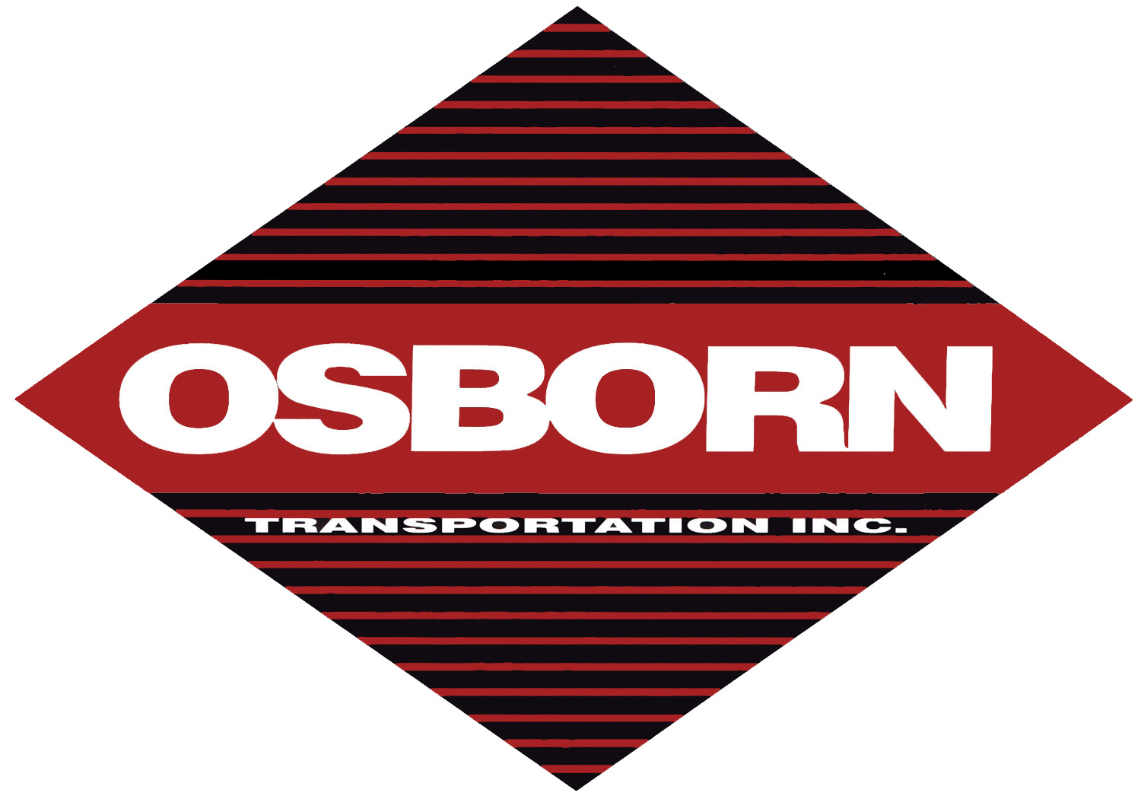
OSBORN TRANSPORTATION INC.

E-Mail Rate Quote

Please fill out the form below and e-mail to: dennis@osborntransportation.com
OR print and fax to Dennis White at: (256) 413-0002

Date: / /
Name Phone # ( ) -
Address
City State Zip Code
E-mail Address

Van / Flatbed Load?
If Flatbed…Then is load oversized? If yes, what are dimensions?
Date of expected movement? Number of Loads
Commodity?
Driver assist? Haz-Mat?

Origin?
Destination?
Include Zip Code if possible

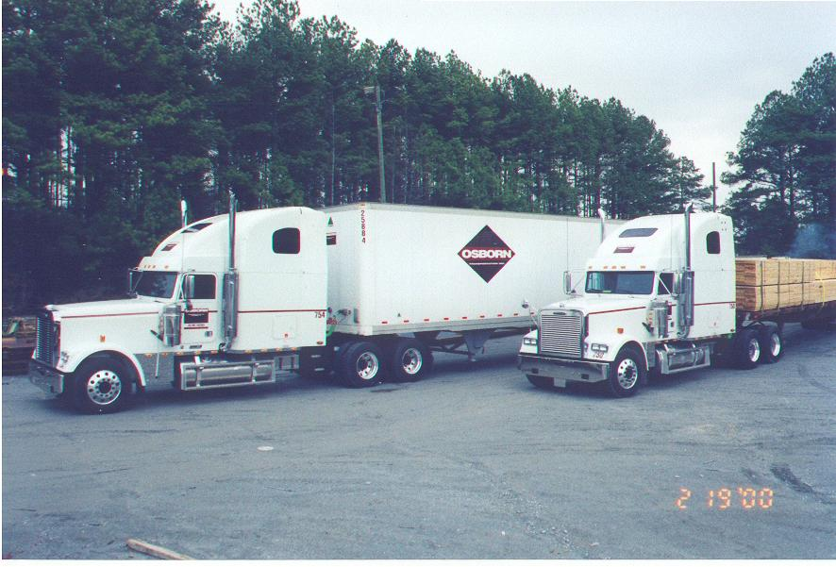
Thank you for allowing us to quote. We will be contacting you by phone or by e-mail.

